Expansion Anchor
for Amazon pegboard
Version 1.0

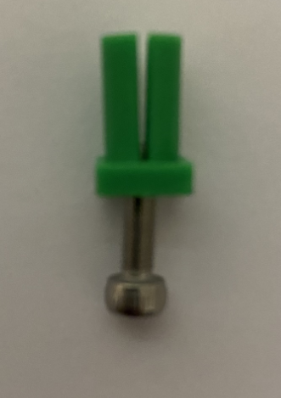

Project Goals
I need a way to fix objects on a pegboard.
I try to use Fischer expansion anchors but they are not good, so I decided to design one by myself.

Expansion Anchor Sketch

Rod and Tip
The rod is 9 mm height
Then there is a 1 mm ring

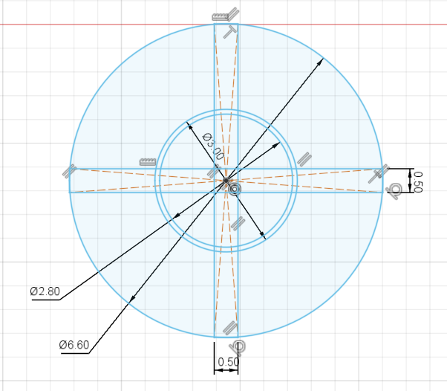 | 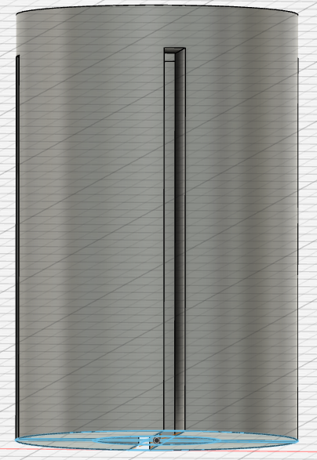

Head
Squared so it is easier to insert the screw
There isn’t enough space to hide the screw
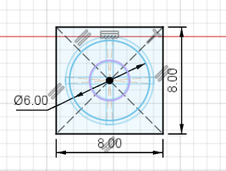 | 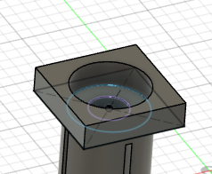

Expansion Anchor Sketch 3D Models
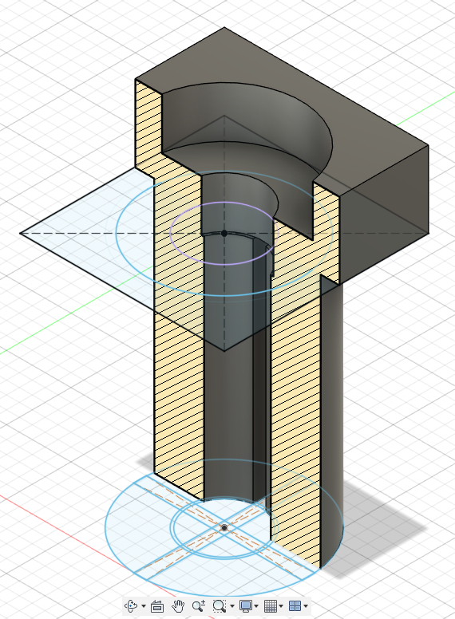

3D Printer layout

Need to be printed with head on top because of the slot for the 3 mm screw

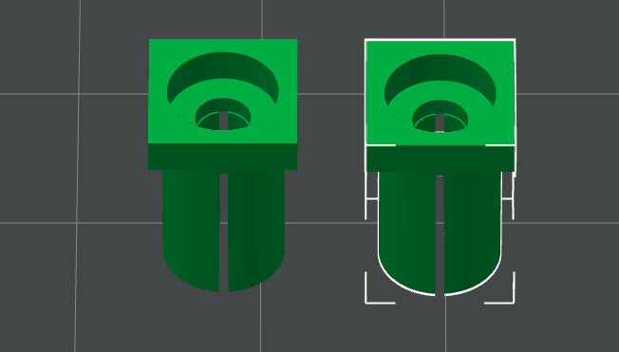

Final result
This is how it looks like normal and expanded.
Not a big change, but it is enough
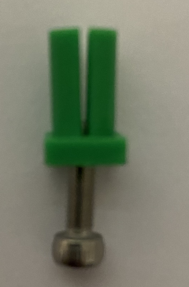 | 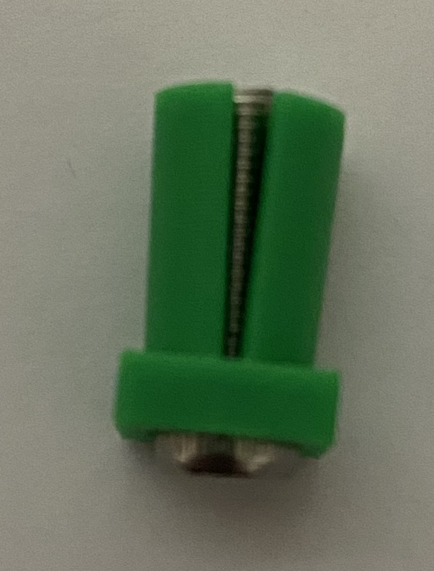

Reference

Amazon Pegboard

Amazon DE: https://amzn.eu/d/8XqDu2Y
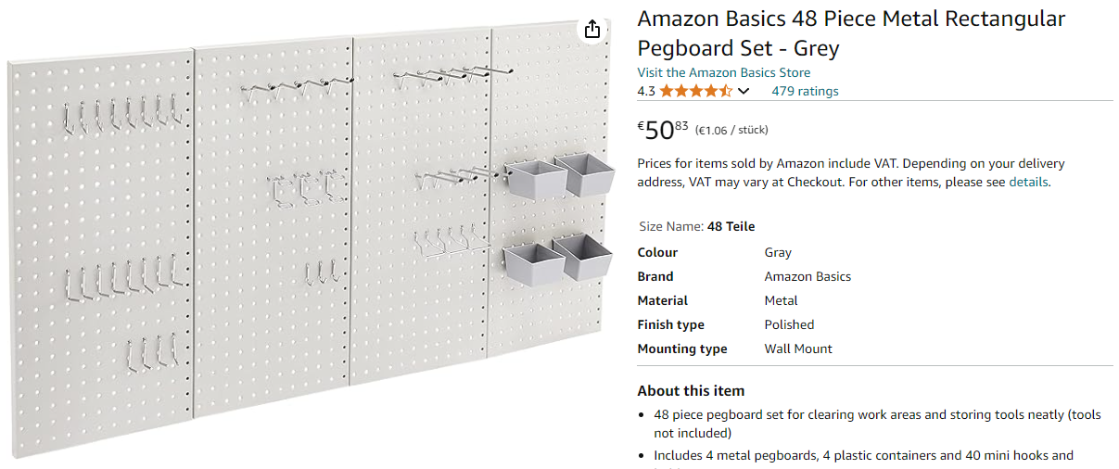

Amazon.it: https://amzn.eu/d/7wQn8La

Holes distance: 25.4 mm
Holes size: 6.6 mm

